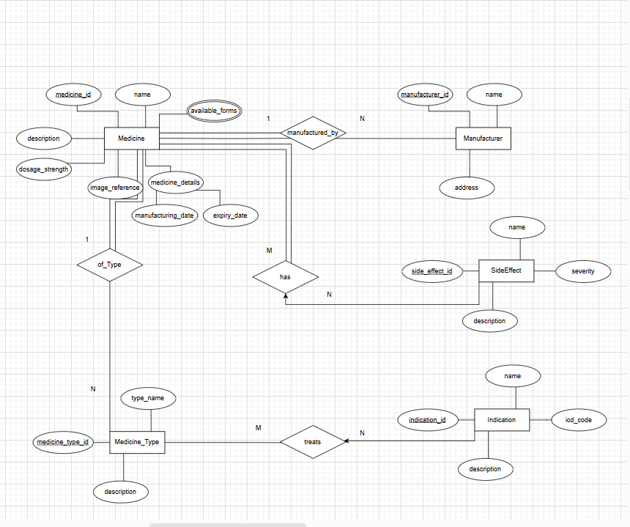

**ER Diagram for Medicine Sorter**